**Group-1**

1. Write a lambda expression which accepts x and y numbers and return xy.
2. Write a method that uses lambda expression to format a given string, where a space is inserted between each character of string. For ex., if input is “CG”, then expected output is “C G”.
3. Employee collection (use Lambda expressions and streams API only for performing operations)

----------------------------------------------------------------------------------------------------------------------

Class :-

Employee(int eId,String eName,int eSalary)

Parameterized Constructor

Getters/setters

class:Main

---------------

add the following methods

Method to display all the Names of Employees getting salary > 50000

Method to display all the names of Employees separated by comma

public int getHighestSalariedEmployee(Employee[] list)

public int getLowestSalariedEmployee(Employee[] list)

public Employee[] rangeOfSalaries(Employee []list, int startingRange, int endingRange)

public int totalNoOFEmloyees()

in main method, do the following:

-create Array of Employee type

-store 5 Employees objects into list created in previous step.

-call all the methods and obtain the results and print them.

**Group-2**

Class :-

Department(dId,dName)

Parameterized Constructor

Getters/Setters

Class :-

Employee(eId,eName,eSalary,eDept)

Parameterized Constructor

Getters/setters

Method to display all the Names of Employees getting salary > 50000

Method to display all the names of Employees separated by comma

Method to compute sum of salaries by department

Method to display only 3 unique salaries.

**Group-3**

Refer the classes given below to represent employees and their departments.

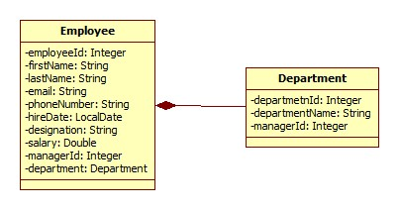

Also refer an EmployeeRepository class which is used to create and populate employee’s collection with sample data.



Create an EmployeeService class which queries on collections provided by EmployeeRepository class for following requirements. Create separate method for each requirement. (**Note:** Each requirement stated below must be attempted by using lambda expressions/stream API. It’s mandatory to solve at least 5 questions from following set. However, it is recommended to solve all questions to understand stream API thoroughly).

* Find out the sum of salary of all employees.
* List out department names and count of employees in each department.
* Find out the senior most employee of an organization.
* List employee name and duration of their service in months and days.
* Find out employees without department.
* Find out department without employees.
* Find departments with highest count of employees.
* List employee name, hire date and day of week on which employee has started.
* List employee name, hire date and day of week for employee started on Friday. (Hint: Accept the day name for e.g. FRIDAY and list all employees joined on Friday)